Creating C Projects in XCode 4.2.1

1. Open up XCode:

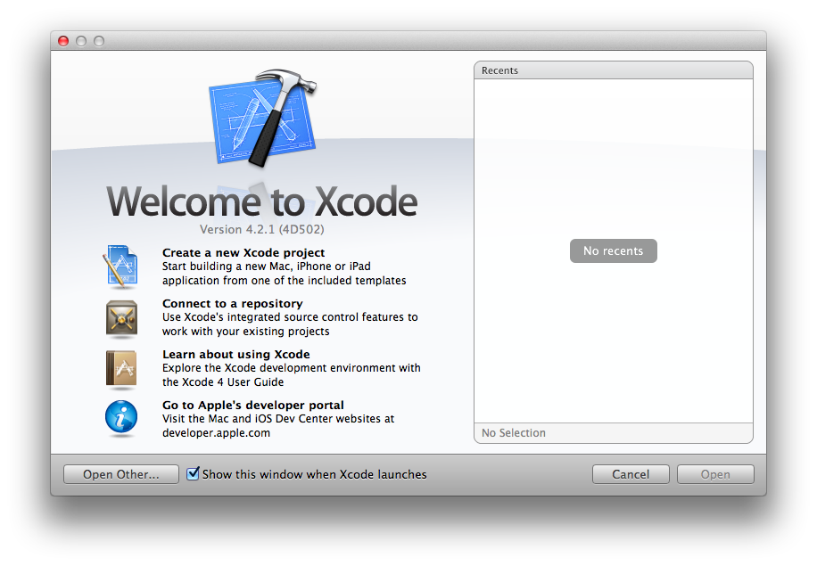

1. Select “Create a new Xcode project”, and you will be presented with:

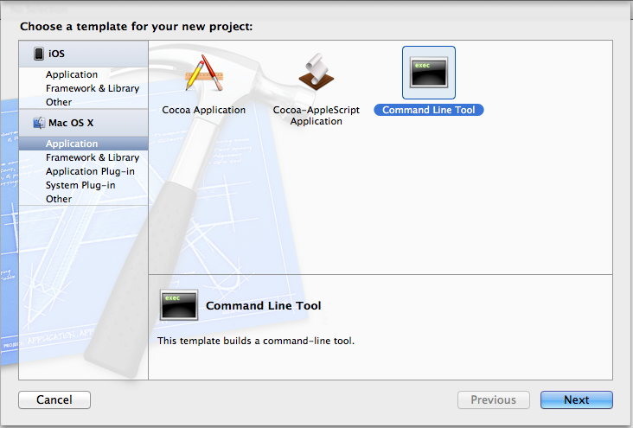

Choose “Command Line Tool” for the application type.

1. Choose a name for the new project (and choose “C” for the Type):

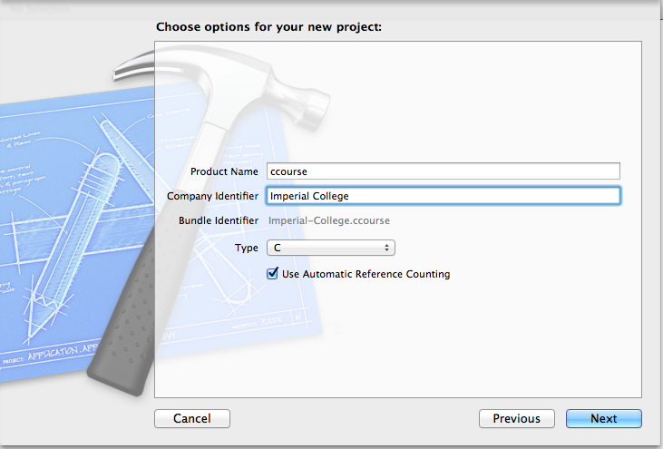

1. Choose a save location for the new project:

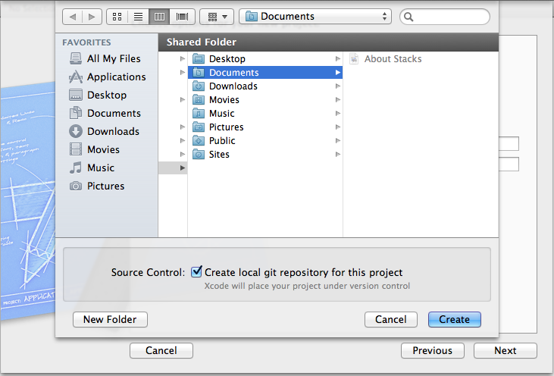

1. A few project settings need to be changed to allow for a standards compliant C code to be more easily built. Click on the icon in the red rectangle below, then click on the header inside the green rectangle then click on the header inside the blue rectangle to navigate to the project settings:

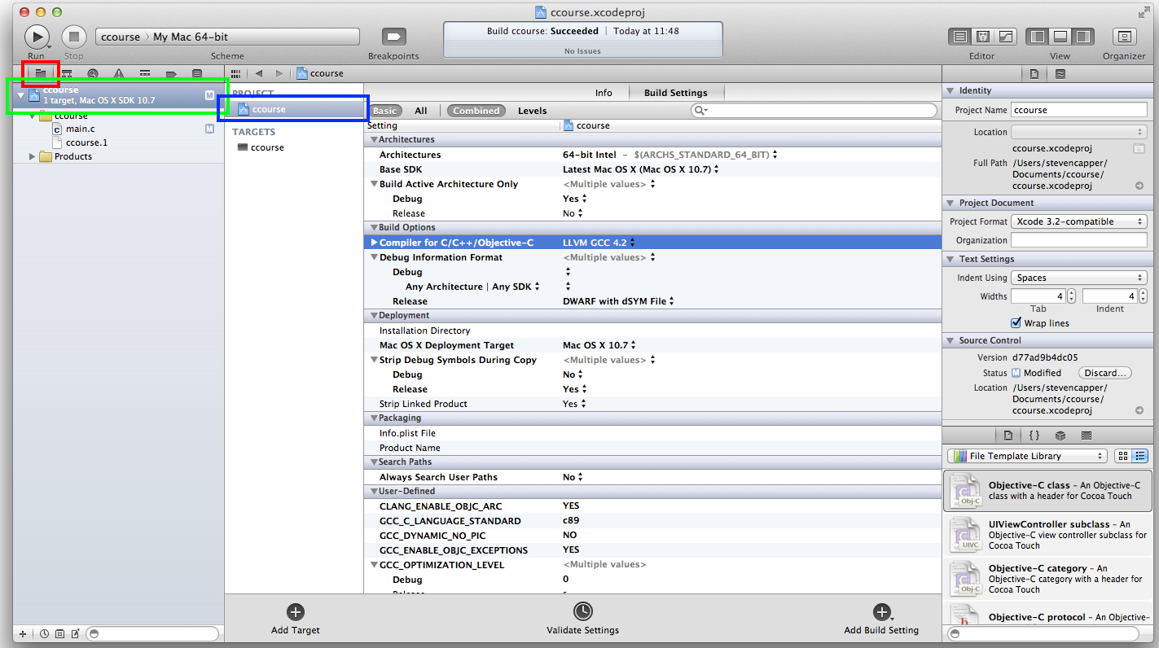

1. Change the C compiler to LLVM GCC 4.2 as follows:

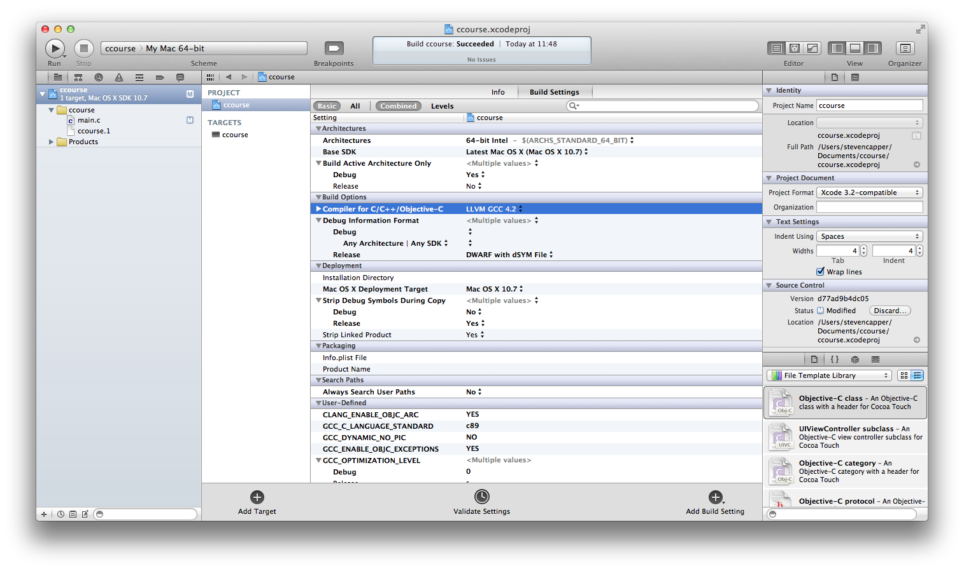

1. Change the C dialect of the project to “C89” as follows:

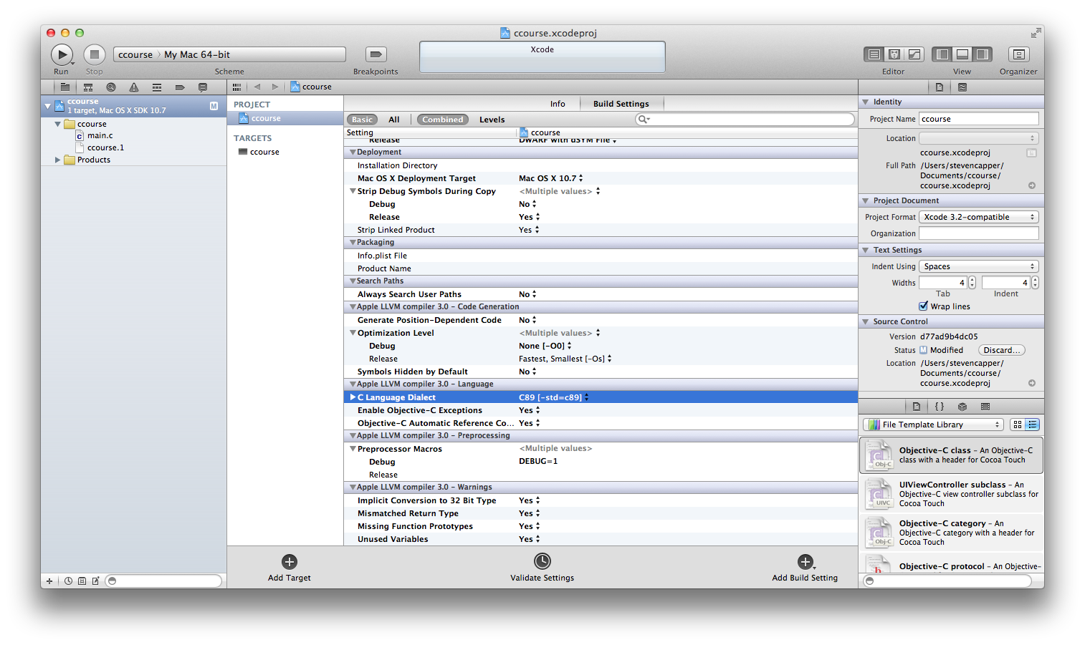

1. Now we need to add one more custom setting, we need to enable pedantic warnings. Click on the button in the red rectangle below. Then click on “Add User-Defined Setting”, and then enter: “GCC_WARN_PEDANTIC” as the setting name and “YES” as the value. It should appear in the build rules below.

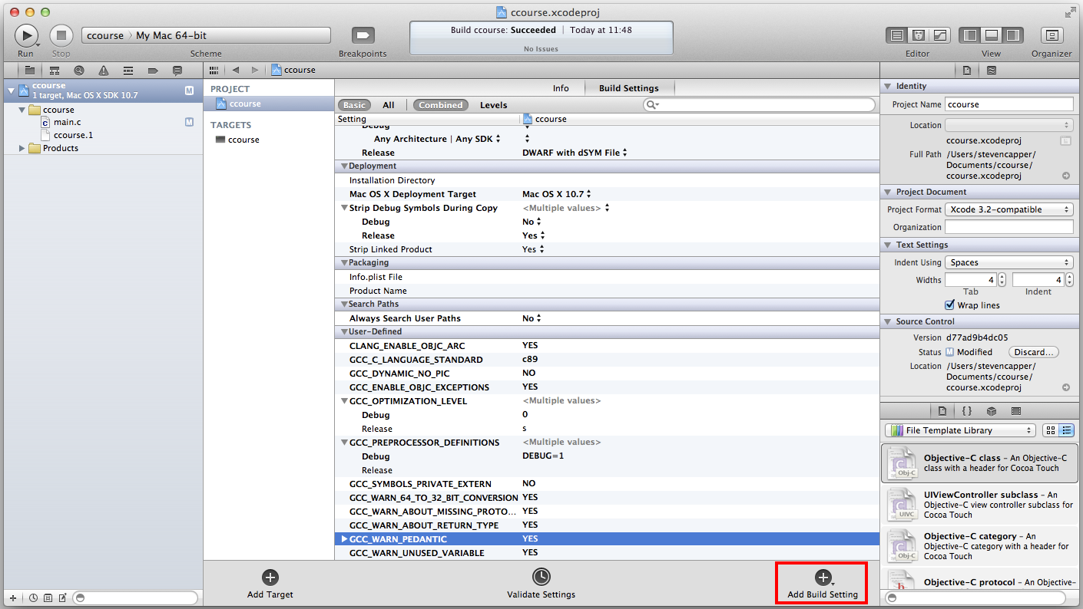

1. Now we will be warned of any ANSI C errors that would not normally be caught by GCC. (Such as declaring a variable in the middle of a code block).

